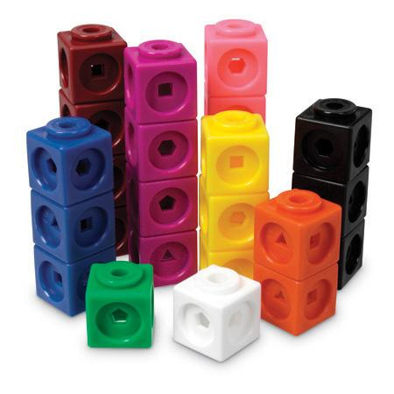
1a) Make a length of 2 blocks.
Name: ______________

1b) Make this length into a square, with sides of 2 blocks. How many blocks are in your square?

1c) Now make the square into a cube, still with sides of 2 blocks. How many blocks are in your cube?

2a) Make a length of 3 blocks.

2b) Make this length into a square, with sides of 3 blocks. How many blocks are in your square?

2c) Now make the square into a cube, still with sides of 3 blocks. How many blocks are in your cube?

3) Complete the following table WITHOUT using the blocks.

 | Number of blocks in square | Number of blocks in cube
Sides of length 2
Sides of length 3
Sides of length 4
Sides of length 5
Sides of length 6

4) Explain how you know how many blocks are in the square without making it.
__________________________________________________________________________________________________________________________________________________________________________

5) Explain how you know how many blocks are in the cube without making it.
_________________________________________________________
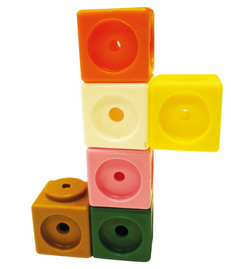
__________________________________________________________________________________________________________________

Challenge!
How many blocks are in a square whose sides are 17 blocks long?
What about a cube?

